Poster 1

# Stakeholder Expectations

* Conceptualize a new Production System
* The new production facility shall be able to produce the current order pattern in addition to the 25 STS cranes per month, both with an optimized manufacturing process.
  + Note: Only manufacturing of the ***required*** parts (After FEM Analysis)

*The current product portfolio, information about the new construction elements, available machines and the order pattern of 4 months (Aug, Sept, Oct, Nov) in 2021 are given in the excel file on Canvas (Datasheet PSE 2022.xlsx). These 4 months are representative for the whole of 2021.*

* The purchase of new machines in order to meet the current order pattern has to be evaluated and must be financially optimal.
* The parts produced should be delivered before the assigned delivery date
* The effects of moving the entire production to a new facility shall remain minimal on the standing orders.
* The floor-map of the new production facility should be optimized to reduce transportation between different machines and increase the overall throughput. Also, minimizing required area reduces cost.

*Internal transport of these parts depends on their size, therefore the layout of these new machines in the factory should be of greater importance.*

* Use FMEA to optimize their production
* No.of employees and man hours
* SPC to monitor and control their processes (Cpk values > 1.5)
* EN-ISO 9001:2015 and AS 9100D certified.
* an OEE (overall equipment effectiveness) of at least 90% for each machine group.
* The new production system should perform as optimally as possible.
* Available production time: 2 shifts/day, 48 weeks/year (8 hour shift)
* The floor space necessary for the new factory should be optimal
* The quality issues with axes for the agricultural customer produced by 3 Turning Machines must be addressed.
* Top priority is on time deliveries & highest quality products & customer satisfaction

Failure Modes and Effects Analysis (FMEA) is a systematic, proactive method for evaluating a process to identify where and how it might fail and to assess the relative impact of different failures, in order to identify the parts of the process that are most in need of change.

Statistical Process Control (SPC) is an industry-standard methodology for measuring and controlling quality during the manufacturing process. Quality data in the form of Product or Process measurements are obtained in real-time during manufacturing.

# Execution

Areas that have to be covered are:

* Requirements and specifications based on an investigation of the problem;
* System architecture;
* Communication;
* Integration (within the sub-system, and with other sub-systems);
* Implementation (what hardware is needed and how is it organized?);
* The design of the individual elements in order to achieve optimal system performance;
* Every group (of 2-3 persons) will design at least one sub-system;
* Testing of the final integrated system.

The production system concept has to be detailed to the point that at least the following questions can

be answered:

* What are the requirements, as seen from the producer(s) of the system, the user and other

relevant stakeholders?

* What subsystems are needed, what are the interfaces, and how are the subsystems integrated

(the architecture of the system)?

* How do the system and its subsystems function?
* What are the costs (both investment and running costs) and the benefits?
* How long is the development program and how many people are needed?
* What will the production system look like, in terms of layout, number of machines, quality system, logistics etc.?
* Are the requirements met?

This results in the following guidelines for the project deliverables:

* Requirements of the system
* Architecture of the system
* Performance and strategy of the production system
* Layout and flow of the system
* Planning and control, capacity and inventory management of the system
* Quality, maintenance and risk management of the system
* Improvement strategy for the system
* Processing of the results of the Statistics case
* Etc.

# Subsystems :

# 

## Finance & Logistics :

* Handle the Logistics of Import of Raw Material Stocks
* Handle the Logistics of Export of Ready Products
* Create Mathematical models to calculate revenue (profit per product, annual profit and Break-even period etc. taking into consideration scrap, rework etc.)

## Performance Management :

* Maintain Quality Standards of the Product
* Maintain Machinery (Maintenance, Startup defects)
* Handle Risk Management, FMEA, Safety

## Planning & Control :

* Schedule Production and Process to meet deadlines
* Maximize Performance, Minimize Idle time
* Optimize OEE of all the Machine Groups
* Handle Rework and Scrap

## Process Design :

* Supply Design Networks
* Create Optimal Factory Layout on the basis of Production Scheduling
* Manage Product Flow inside the factory
* Manage Resources (Human : Staff, Natural : Products in Factory, Assets : Machinery)

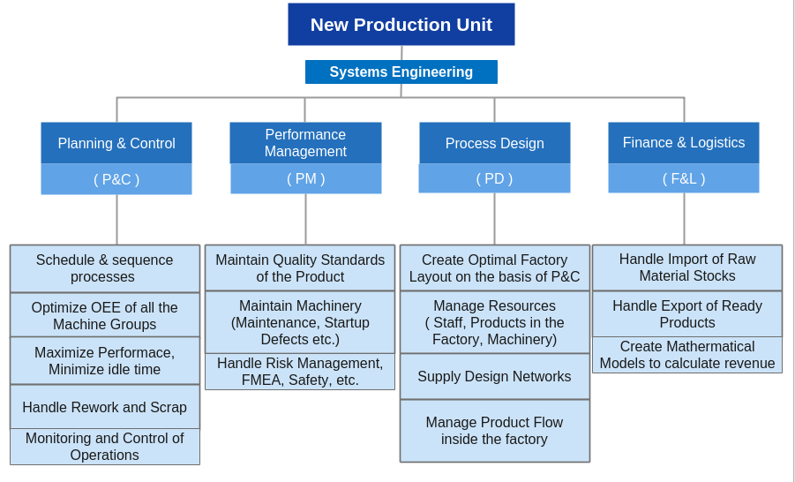

# Architecture

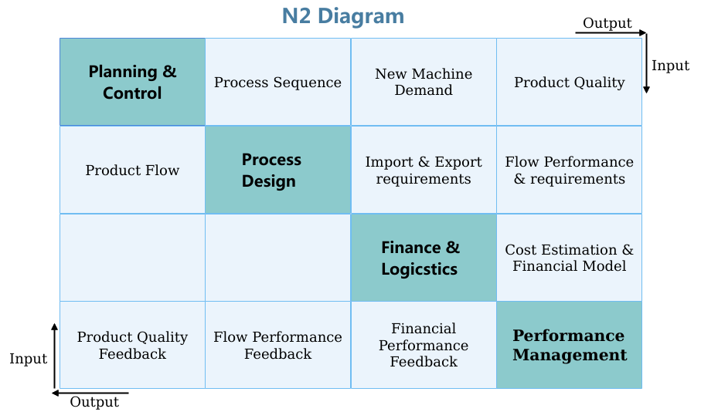

| 1. **P&C** generates the schedule and **Process Sequence** according to the requirements to be met. This Process Sequence is conveyed to the **PD** to plan the layout and the placement of machinery which govern the Product Flow through the manufacturing unit. 2. **P&C** identifies which of the machinery is insufficient (bottleneck) and new ones needed to meet the production requirements. The **New Machine Demand** is conveyed to **F&L**. 3. **P&C** is aware of machine defects and conveys information regarding the **Product Quality** of the produced items to **PM.** 4. **PD** handles the Warehousing and Product Flow around the Production Unit (aware of the Production Plan given by P&C which is carried out).Hence PD conveys the **Import & Export Requirements** to **F&L** 5. **PD** needs Man-power and other resources to carry out the process. The information about **Flow Performance** (transport time of goods, space utilization for warehousing etc.) and **Requirements** (manpower and other resources) is conveyed to **PM** 6. With the Data given to **F&L**, it carries out **Cost Estimation** & creates the **Financial Model** of the Production System. This is conveyed to the **PM** which records the financial Performance. |
| --- |

1. **PM** gives Feedback regarding **Product Quality**, **Flow Performance** and **Financial Performance** to **P&C**, **PD** and **F&L** respectively, and the optimization is carried out iteratively.

Poster 2

# <https://www.projectmanager.com/blog/requirements-analysis-stakeholder-satisfaction>

Requirements must be:

* Documented
* Actionable
* Measurable
* Testable
* Traceable
* Related to identified business needs or opportunities
* Defined with enough detail to be enough for system design

https://enkonix.com/blog/functional-requirements-vs-non-functional/

<https://www.altexsoft.com/blog/business/functional-and-non-functional-requirements-specification-and-types/>

<https://www.javatpoint.com/functional-vs-non-functional-requirements>

<https://reqtest.com/requirements-blog/functional-vs-non-functional-requirements/>

In this International Standard, the following verbal forms are used:

* — “shall” indicates a requirement;
* — “should” indicates a recommendation;
* — “may” indicates a permission;
* — “can” indicates a possibility or a capability.

EN-ISO 9001:2015<https://www.iso.org/obp/ui/#iso:std:iso:9001:ed-5:v1:en> and AS 9100D standards are met<http://assem-tech.com/wp-content/uploads/2019/03/AS9100D.pdf>

<https://www.osha.gov/sites/default/files/publications/emergency-exit-routes-factsheet.pdf>

Stakeholders’ Power vs Interest

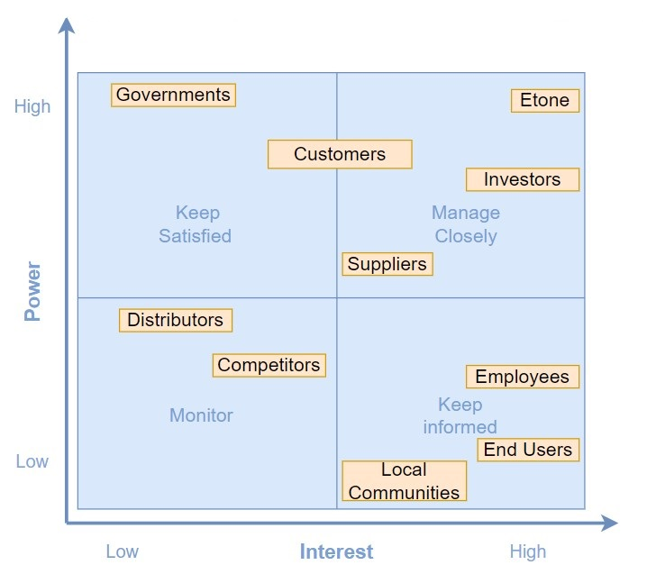

# 

# 

# Stakeholder Requirements(Functional - Quant. NF:flexibi. etc.) (should/shall) (Must - Shall - Could - Want/Wish)

**Suppliers & Distributors**: responsible for raw material supply and final product transport

* Requirement of raw materials for Etone and its customers (Consistent (<10% variation) Order Patterns)

**Local Communities & Employees**: affected by the Production System and end products in many ways

* Employment of people in the factory (Human Resource Requirement)
* How the system affects the environment around it (Waste Produced)

**Port of Ashdod & End-user:** End-user/ distributors of the cranes

* They are interested in the timely delivery of the orders (Order Pattern is met)
* Safety of operation of the cranes by the operators (iFEM Analysis)

**Investors**: have invested in the Production System / Etone

* Financial Model (depreciating assets, profits, costs, liquidity, etc), and Financial Prediction
* % waste, % recycling, %efficiency, employment (SPC to monitor/control processes,Cpk values > 1.5,OEE)

**Governments (EU):**

* Quality of products produced fits the EU standards/ norms (EN-ISO 9001:2015 and AS 9100D certified)
* Safety of Production System (FMEA)

**Etone:**

* Meeting order patterns
* Maintaining profit
* Maintaining quality of products
* Reusing all old machinery
* Reduce floor area
* Reduction in idle time

# Functions:

* Predict costs
* Generate Order Pattern Plan
* Produce Products in time for timely delivery
* Estimate Workforce Requirements
* Design Floorplan
* Manage inventory and warehousing
* Schedule production
* Monitor and manage production
* Maintain product quality
* Ensure timely machine maintenance and perform machine failure analysis
* Calculate % reused, % wasted
* Predict the number of new machines needed

**Stakeholder Requirements:**

Suppliers: (F&IM)

* **F** regular and reliable raw material order patterns with a < 10% variation
* **F** Safety Stock : < n %, not more than n % of the ordered raw materials is unused

All Customers:

* **NF** Order delivery: specified delivery dates and number of parts are met with minimal variation (ensure by keeping safety stock) == dependability (PP&C, F&IM, QC&RM)
* **F** Quality: Cpk > 1.5 (the ability of a process to produce output within specification limits) (QC&RM)

Investors:

* **F** Cost of new machinery required [Initial Investment] (F&IM)
* **F** Should reach breakeven point in t years (F&IM)
* **F** Production efficiency: OEE >= 90% overall (PP&C)
* **F** Material Usage Efficiency: less than r% wasted product and material (QC&RM) == shaft less than 600 for agriculture part. Statistical analysis and rework allocation

Port of Ashdod:

* **F** horizontal displacement of boom tip <= 4mm (QC&RM)

Etone:

* **F** Material Usage Efficiency: less than 5% wasted product and material (QC&RM)
* **F** maximum walking distance d m (PFD)
* **NF** easy access to safety exits (not blocked by machines/ keep in mind the walking distance) (PFD)
* **F** safety exits at least 0.7 m wide (PFD)
* **F** Should reach breakeven point in t years (F&IM)
* **NF** failure modes are minimized (FMEA analysis) and (QC&RM) == quantify (numbers and units)
* **NF** ISO standards are met (QC&RM)
* **F** product_transit_time/production_time < layout_eff % (PFD) [throughput]
* **NF** Flexibility (PP&C)
* **F** standard working hours 2 shifts/day, 48 weeks/year (PP&C) (F&IM)
* **F** minimum working wage (F&IM)

Governments:

* **F** Material Usage Efficiency: less than 5% wasted product and material (QC&RM)
* **F** safety exits at least 0.7 m wide (PFD)
* **F** minimum working wage (F&IM)

**Subsystem Requirements:**

**NF== non functional requirement F== Functional Requirement**

PP&C:

* **NF** Order delivery: specified delivery dates and number of parts are met with minimal variation (ensure by keeping safety stock) == dependability
* **F** Production efficiency: OEE >= 90% overall
* **NF** Flexibility
* **F** standard working hours 2 shifts/day, 48 weeks/year

PFD:

* **F** maximum walking distance d m
* **NF** easy access to safety exits (not blocked by machines/ keep in mind the walking distance)
* **F** safety exits at least 0.7 m wide
* **F** product_transit_time/production_time < layout_eff % [throughput]

F&IM:

* **F** regular and reliable raw material order patterns with a < 10% variation
* **F** Safety Stock : < n %, not more than n % of the ordered raw materials is unused
* **NF** Order delivery: specified delivery dates and number of parts are met with minimal variation (ensure by keeping safety stock) == dependability
* **F** Cost of new machinery required [Initial Investment]
* **F** Should reach breakeven point in t years
* **F** standard working hours 2 shifts/day, 48 weeks/year
* **F** minimum working wage

QC&RM:

* **NF** Order delivery: specified delivery dates and number of parts are met with minimal variation (ensure by keeping safety stock) == dependability
* **F** Quality: Cpk > 1.5 (the ability of a process to produce output within specification limits)
* **F** Material Usage Efficiency: less than r% wasted product and material == shaft less than 600 for agriculture part. Statistical analysis and rework allocation
* **F** horizontal displacement of boom tip <= 4mm
* **F** Material Usage Efficiency: less than 5% wasted product and material (QC&RM)
* **NF** failure modes are minimized (FMEA analysis) and (QC&RM) == quantify (numbers and units)
* **NF** ISO standards are met (QC&RM)

Key Drivers v1

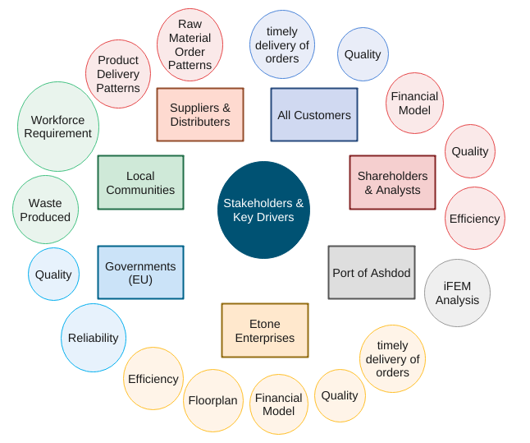

Revised Key Drivers

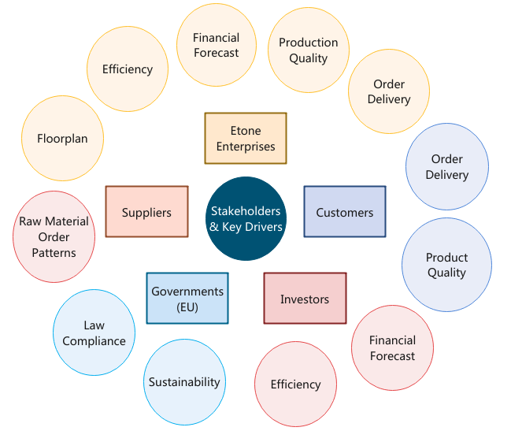

Key Drivers to KPIs

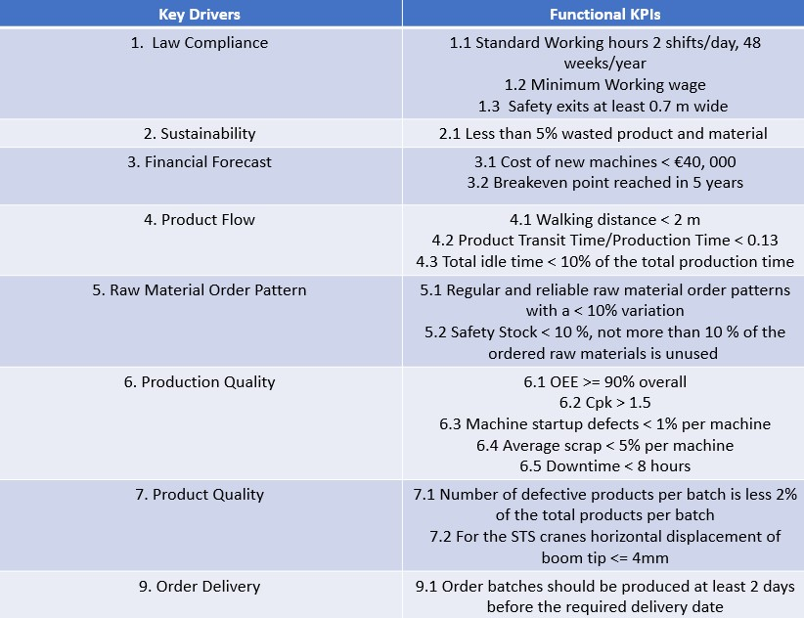

KPI to Subsystems

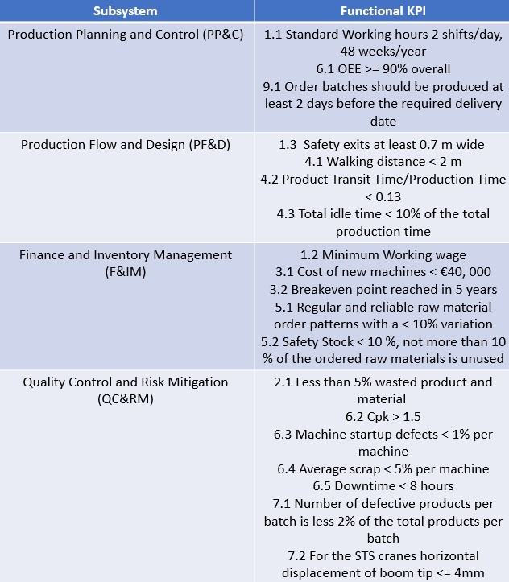

Operational Architecture / Functional Flow

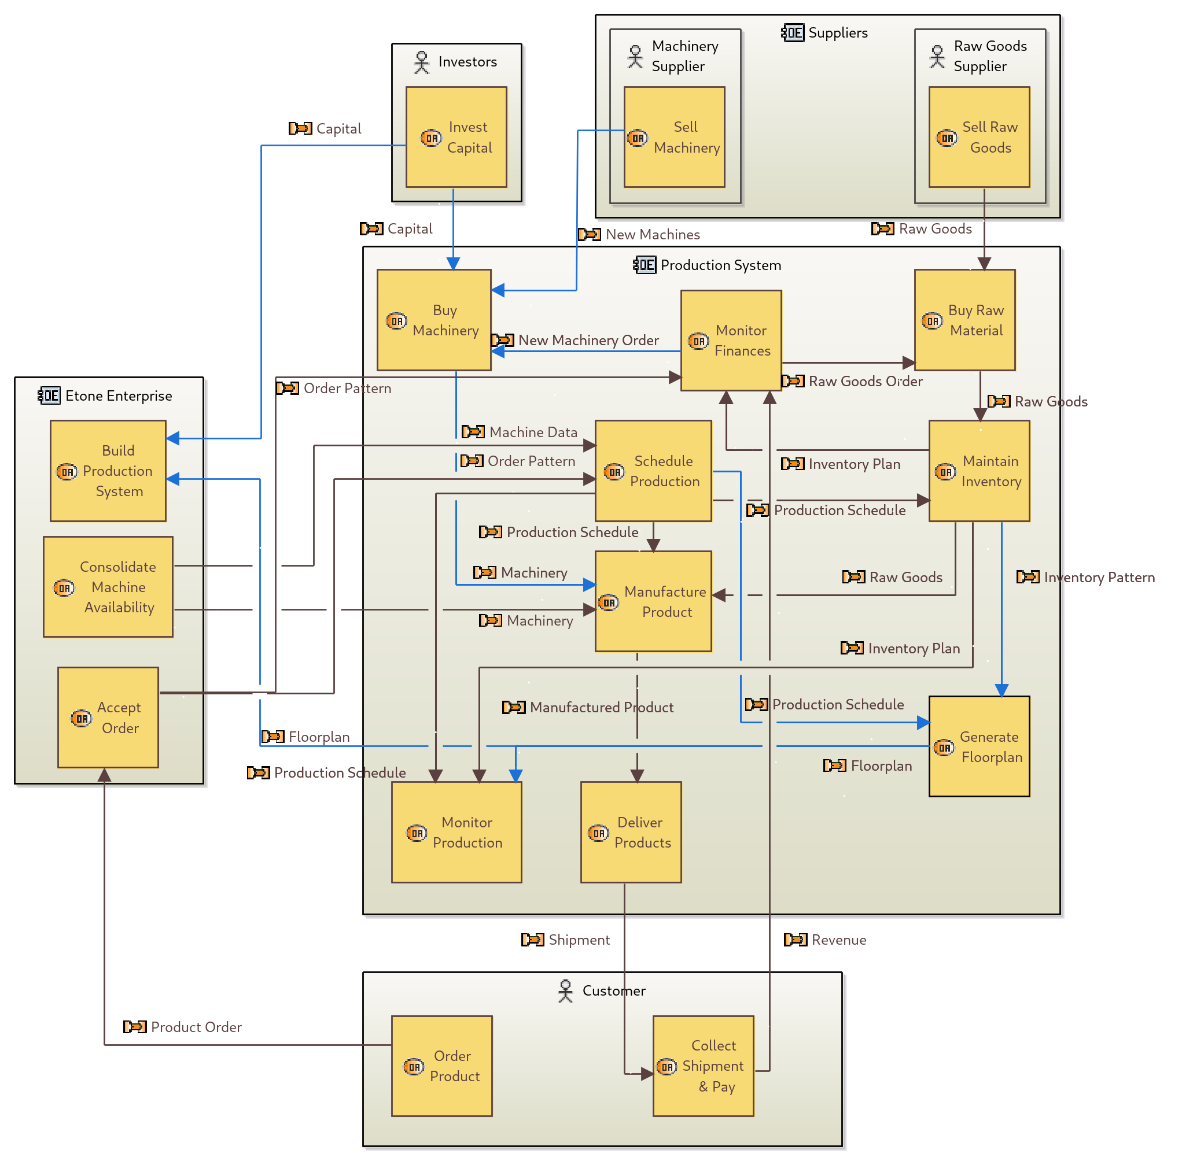





Subsystems Explained

# Production Planning & Control (PP&C)

Schedule production including predicted maintenance time based on the data in the excel. Production Schedule includes production sequence for the delivery of the end product. They take into account the startup defects as well. This is the planning part.

They get input from the PM about the preventive and corrective protocol and implement that in the production schedule when there are defects (they receive the failure protocol). The control part consequently affects the finance and inventory part.

# Finance & Inventory Management (F&IM)

They receive the production schedule. They create a list of raw materials, new machines and staff needed and use that for cost prediction as well as Inventory Management and warehousing.

# Production Flow & Design (PF&D)

They receive information about the production schedule and sequence from P&C and warehousing information from F&IM in order to create the optimum floor plan layout so that interdependent machines are grouped in order to minimize the ide time while keeping in mind the safety of the floorplan layout and keeping enough space for inventory.

# Quality Control & Risk Mitigation (QC&RM)

They receive the inputs from the different subsystems and do a risk and FMEA analysis. They maintain quality control based on statistical models by deriving a preventative and corrective protocol (including maintenance strategy) in case failure occurs during production. They present the FEM analysis of the cranes since this can be seen as a risk preventative method for ensuring the end product quality is met.

The preventative protocol from PM is given to the different subsystems again so that they can reimplement it in their subsystems. This mainly concerns P&C and F&IM. So they redesign the production schedule and inventory by implementing the maintenance strategy and keeping a safety stock in the warehouse in order to lower the risk of inactive operations.

Checklist

# Design Review Feedback

* ~~Think about simplifying subsystems~~
* ~~Finance & Logistics may not be big enough~~
* ~~Take into account all stakeholders for requirements~~
* ~~Make requirements clear/ detailed~~
* Connectivity with stakeholders and polar diagram
* Create functional flow diagram from SE diagram to make sure no functions are missing
* ~~Not only STS cranes but also other production lines and its stakeholders’ requirements should be taken into account~~

# Functions:

* ~~Predict costs~~
* ~~Generate Order Pattern Plan~~
* ~~Produce Products in time for timely delivery~~
* ~~Estimate Workforce Requirements~~
* ~~Design Floorplan~~
* ~~Manage inventory and warehousing~~
* ~~Schedule production~~
* Monitor and manage production
* Maintain product quality
* ~~Ensure timely machine maintenance and perform machine failure analysis~~
* Calculate % reused, % wasted
* ~~Predict the number of new machines needed~~

# Content Continuity:

* ~~(Poster) Problem Statement (SALLY)~~
* ~~(Handout)Stakeholder Analysis ( High/Low Power vs Active/Passive Involvement) (SALLY)~~
* ~~(Poster)Stakeholders & Key Drivers~~
* ~~(Handout) Key-Driver to Kpi Mapping,(SALLY)~~
* ~~(Handout) System Requirements [FORMAT] (KP) update after Sally updates~~
* ~~(Poster) Functional Flow (have numbered interfaces which are used in N2 Architecture) (KP)~~
* ~~[ IGNORE ] Functional N2 Architecture (KP)~~
* ~~(Handout) FunKey Coupling Matrix (KP)~~
* ~~(Poster) N2 Architecture (Integration) (KP)~~
* ~~(Handout) System explanation [FORMAT] (SALLY)~~
* ~~(Handout) Kpi to Subsystem Mapping~~
* (Handout) Design Tests (SALLY)
* (Posters) Matrix of kpi (rows), and tests (columns) and see that all are met (SALLY)
* ~~[ IGNORE ] Validation —> leads back to stakeholders [IGMORE]~~
* ~~(Poster) Conclusion~~

<https://www.dotactiv.com/floor-planning>